

LOGIN

Yes

Log out

Parent

Teacher

Student

Admin

School Management System

Log in Authenticate

Register Admin/User

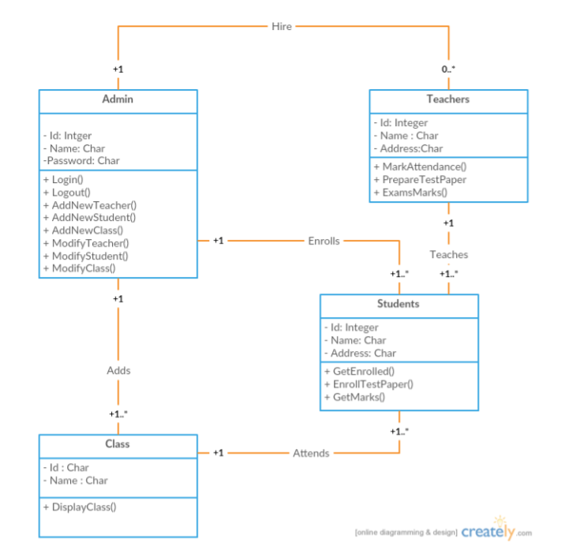



Attendance, fee receipt, report

Student details, fee details

ENTER STUDENT MARKS, ATTENDENCE, PERFORMANCE



VIEW CHILD MARKS, ATTENDENCE, FEE NOTIFICATIONS